Khaira Arby
Live in New York
CLE033
UPC-LP 711574917815
UPC-CD 711574917822
UPC-DI 195497339747

Album cover artwork

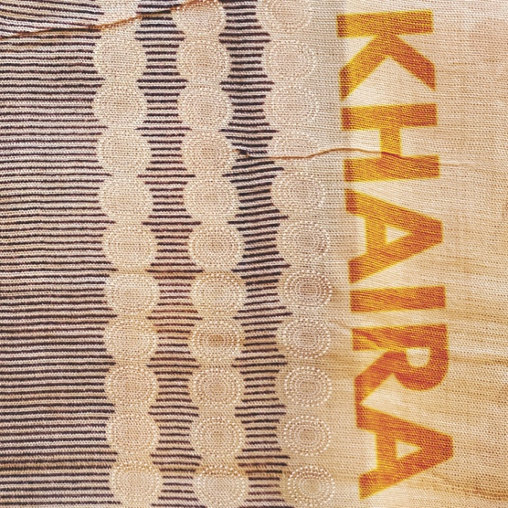

Liner notes
As the lights dim and Malian diva Khaira Arby steps into the spotlight, the audience jumps up with shouts and cheers. People loved the late Khaira Arby for the fire and passion of her voice. Pushing boundaries, Khaira triumphs as this recently restored concert recording testifies.

Recorded live August 2010 at Fisher Center at Bard, SummerScape, Annandale-on-Hudson, New York.

CD & DI Tracklist
1 Ya Rassoul QMPGD2000030 6:12
2 Sourgou QMPGD2000031 7:43
3 Gourmou QMPGD2000032 7:57
4 Delya QMPGD2000033 6:46
5 Salou QMPGD2000034 6:33
6 Youba QMPGD2000035 6:20
7 Ferene QMPGD2000036 7:11
8 Haidara Moulaye QMPGD2000037 8:10
9 Laurou QMPGD2000038 6:06
10 Aicha QMPGD2000039 6:10

LP Tracklist
Side A
1 Sourgou QMPGD2000031 7:43
2 Gourmou QMPGD2000032 7:57
3 Delya QMPGD2000033 6:46
Side B
1 Ferene QMPGD2000036 7:11
2 Haidara Moulaye QMPGD2000037 8:10
3 Laurou QMPGD2000038 6:06

Khaira Arby vocal
Dramane Toure lead guitar
Mahalmadane Abbanassane Traore percussion
Abellow Yattara tehardant/ngoni
Mohamed Ag Mohamed bass guitar
MBarka Dembele rhythm guitar
Abdrahamane Addey Faradji backup vocal
Inna Diarra backup vocal

Written, composed and arranged by Khaira Arby with Mahalmadane A Traore,
Dramane Toure and Dedeou H Traore
All tracks mastered by Dave Cook, Area 52 Studios, Saugerties, NY and
Jon Cohrs, Bearcall Mastering, Kingston NY
Produced by Christopher A Nolan, Clermont Music, Germantown, NY
Graphic design by Andrew Nelson, Down in the Valley Designs, Kingston NY
Photos: Clermont Music
© ℗ Copyright 2021 - Nolan & Associates Productions LLC, Germantown NY
Special thanks to: Caleb Hammons, Bard SummerScape, Fisher Center at Bard, Bard College, and to Raissa St Pierre www.fishercenter.bard.edu

Genre
World Music, Desert Blues, afrorock, Timbuktu, female vocalist

Hashtags
Khaira Arby, Khaira, Haira, Live in New York, Timbuktu, Tombouctou, Sahara Desert, Sahel, Mali, Africa, Songhai, desert blues, world music, female vocalist, Clermont Music, CLE033, Fisher Center at Bard, Spiegletent, Bard Summerscape

Lyric summary:

1 Ya Rassoul QMPGD2000030 6:12
A religious chant. Ya rassoul Allah. In praise of Allah. A blessing on the people assembled and the evening.

2 Sourgou QMPGD2000031 7:43
A praise song about the bravery and values of the Tamashek. They are righteous, proud, and fierce fighters.

3 Gourmou QMPGD2000032 7:57
A song about the Islamic religious festival Mahoulid which is held in April.

4 Delya QMPGD2000033 6:46
A mythic tale of the dancer, Delya. Paralyzed in an accident and he could no longer dance. When his friends came to visit he said: Don’t forget me when I’m gone. I will be filled with happiness whenever you play music and dance.

5 Salou QMPGD2000034 6:33
A song of prayer to Allah.

6 Youba QMPGD2000035 6:20
A song about the salt miners of Taoudenni. Their exhausting work, the heat and thirst. Their hunger and the hard work in the mines.

7 Ferene QMPGD2000036 7:11
A song condemning the practice of female excision.

8 Haidara Moulaye QMPGD2000037 8:10
A traditional praise song performed in honor of Cheicknè Moulaye, a great fan, benefactor and supporter of Khaira and her musicians.

9 Laurou QMPGD2000038 6:06
The title of the song refers to the era of Arab slavery. It is a part of Khaira’s heritage and she sings that she is proud of her heritage.

10 Aicha QMPGD2000039 6:10
A traditional song praising a young woman, Aicha, who helped everyone in need.

